Bash Script Tasks
- Create a bash script tocheck if a directory is available or not.

Step 1: Create the script
vi check_directory.sh
Step 2: Write the script
#!/bin/bash  DIR="/home/ubuntu/test"  if [ -d "$DIR" ]  then  echo "Directory exists."  else  echo "Directory does not exist."  fi  Output: Directory does not exist. | #!/bin/bash  DIR="/home/ubuntu/Check_Directory"  if [ -d "$DIR" ]  then  echo "Directory exists."  else  echo "Directory does not exist."  fi  Output: Directory exists.

Step 3: Save the file
Press Esc
Type:
:wq
Press Enter
Step 4: Give execute permission
chmod +x check_directory.sh
Step 5: Execute the script
./check_directory.sh
Output
Directory exists.
or
Directory does not exist.
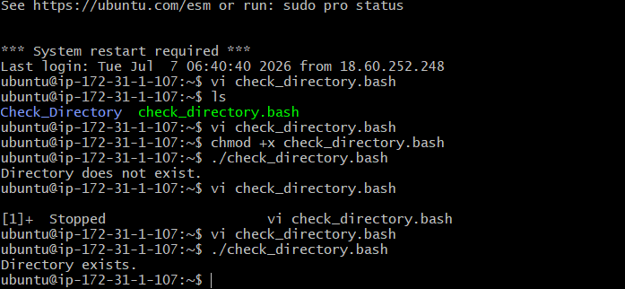

- Create a bash script “to create multiple files.”

2. Create Multiple Files
Step 1
vi create_files.sh
Step 2
#!/bin/bash
touch file1.txt file2.txt file3.txt file4.txt file5.txt
echo "Files created successfully."
Step 3
Save the file.
Esc
:wq
Step 4
chmod +x create_files.sh
Step 5
./create_files.sh
Step 6
Verify
ls
Output
file1.txt
file2.txt
file3.txt
file4.txt
file5.txt

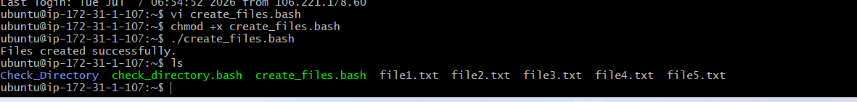

- Create a bash script to take a backup of a directory.

3. Take Backup of a Directory
Suppose
Source directory:
/home/ubuntu/project
Backup directory:
/home/ubuntu/backup
Step 1
vi backup.sh
Step 2
#!/bin/bash
SOURCE_DIR="/home/ubuntu/project"
BACKUP_FILE="/home/ubuntu/backup_$(date +%F).tar.gz"
tar -czf "$BACKUP_FILE" -C "$(dirname "$SOURCE_DIR")" "$(basename "$SOURCE_DIR")"
echo "Backup completed."
Step 3
Save
Esc
:wq
Step 4
chmod +x backup.sh
Step 5
./backup.sh
Step 6
Verify
ls /home/ubuntu/backup
Output
project_2026-07-04.tar.gz

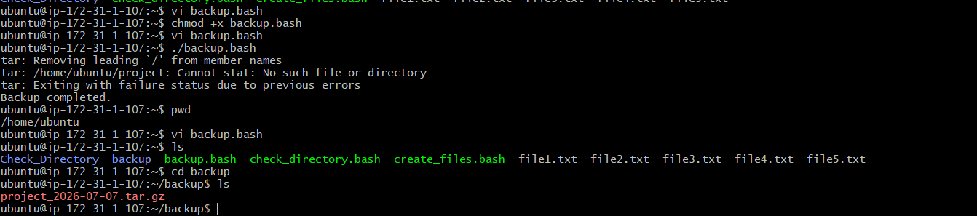

- Create a bash script toinstall Nginx on an EC2 server.

Step 1
vi install_nginx.sh
Step 2
#!/bin/bash

sudo apt update

sudo apt install nginx -y

sudo systemctl enable nginx

sudo systemctl start nginx

echo "Nginx Installed Successfully"
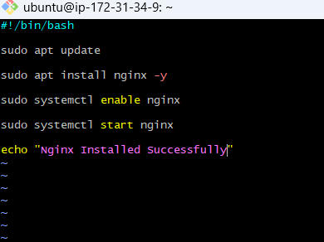

Step 3

Save

Esc
:wq
Step 4
chmod +x install_nginx.sh
Step 5
./install_nginx.sh
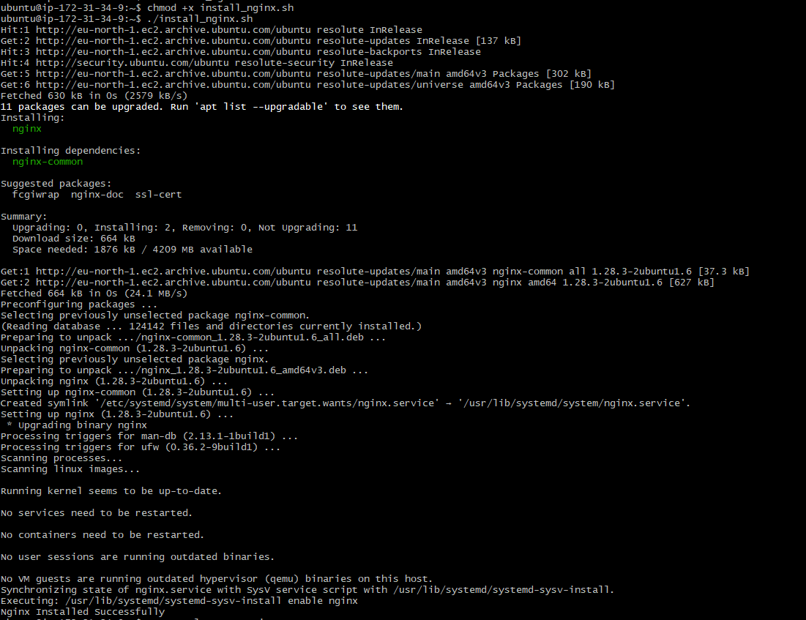

Step 6
Verify
systemctl status nginx
or
curl localhost
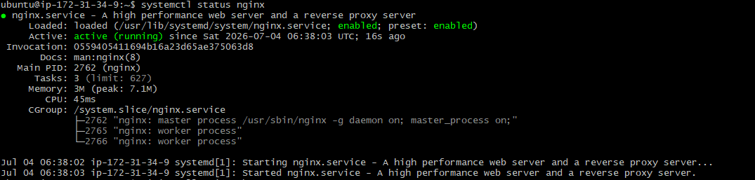

- Create a bash script toinstall Apache Tomcat on an EC2 server.
Step 1: Create the script
nano install_tomcat.sh
Step 2: Copy and paste the following script
#!/bin/bash

echo "Updating packages..."
sudo apt update -y

echo "Installing Java 17 and wget..."
sudo apt install openjdk-17-jdk wget -y

echo "Checking Java Version..."
java -version

echo "Moving to /opt directory..."
cd /opt

echo "Downloading Apache Tomcat 11..."
sudo wget https://downloads.apache.org/tomcat/tomcat-11/v11.0.11/bin/apache-tomcat-11.0.11.tar.gz

echo "Extracting Tomcat..."
sudo tar -xzf apache-tomcat-11.0.11.tar.gz

echo "Renaming Tomcat folder..."
sudo mv apache-tomcat-11.0.11 tomcat

echo "Giving execute permission..."
sudo chmod +x /opt/tomcat/bin/*.sh

echo "Starting Tomcat..."
sudo /opt/tomcat/bin/startup.sh

echo "Checking Tomcat status..."
sudo ss -tulnp | grep 8080

echo "Tomcat Installation Completed Successfully."
echo "Open in browser: http:// 98.130.47.89: 8080"
Step 3: Save the file
- Press Ctrl + O
- Press Enter
- Press Ctrl + X
Step 4: Give execute permission
chmod +x install_tomcat.sh
Step 5: Run the script
./install_tomcat.sh
or
bash install_tomcat.sh
Before opening Tomcat in the browser
Make sure your AWS EC2 Security Group has an inbound rule:
Type | Protocol | Port | Source
Custom TCP | TCP | 8080 | 0.0.0.0/0
Then open:
http:// 98.130.47.89:8080

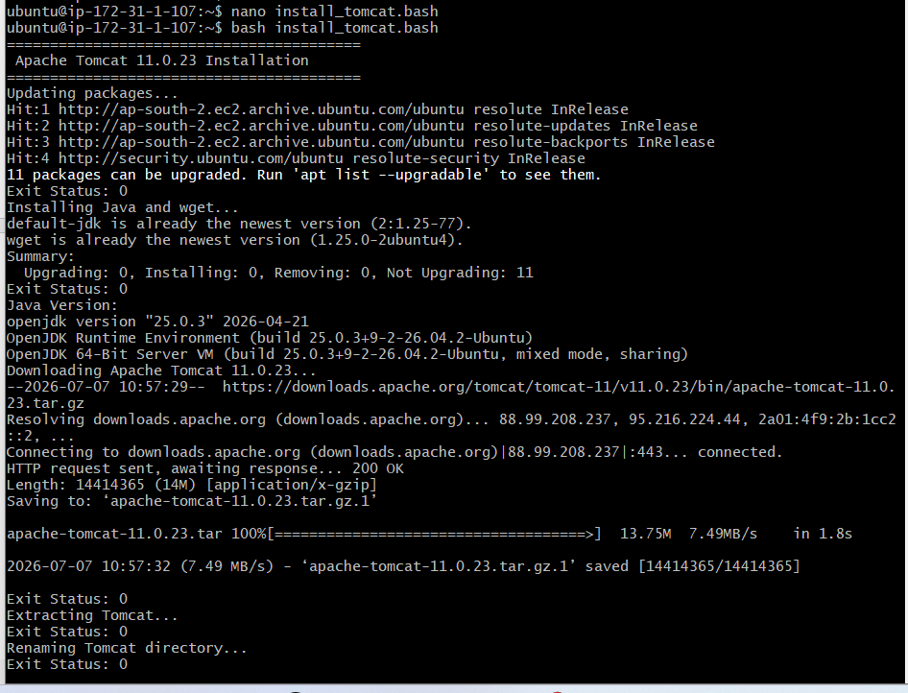

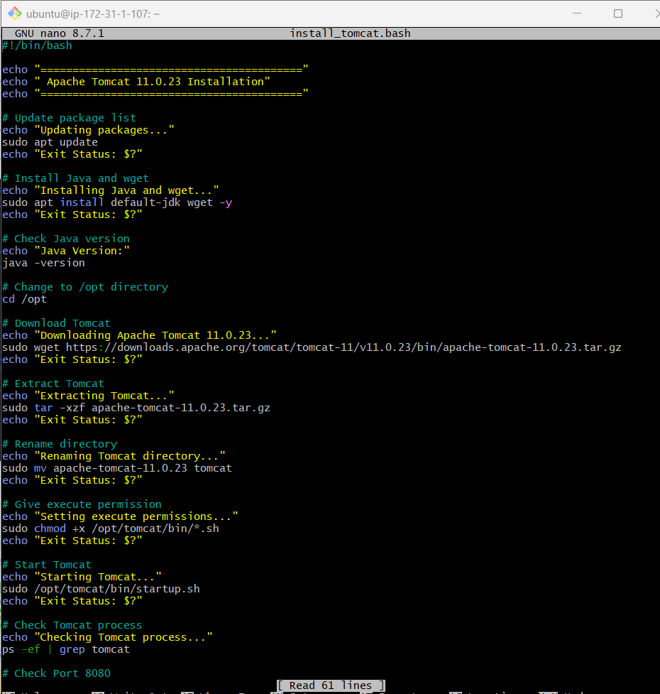
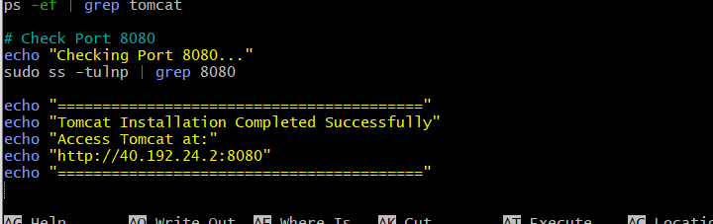

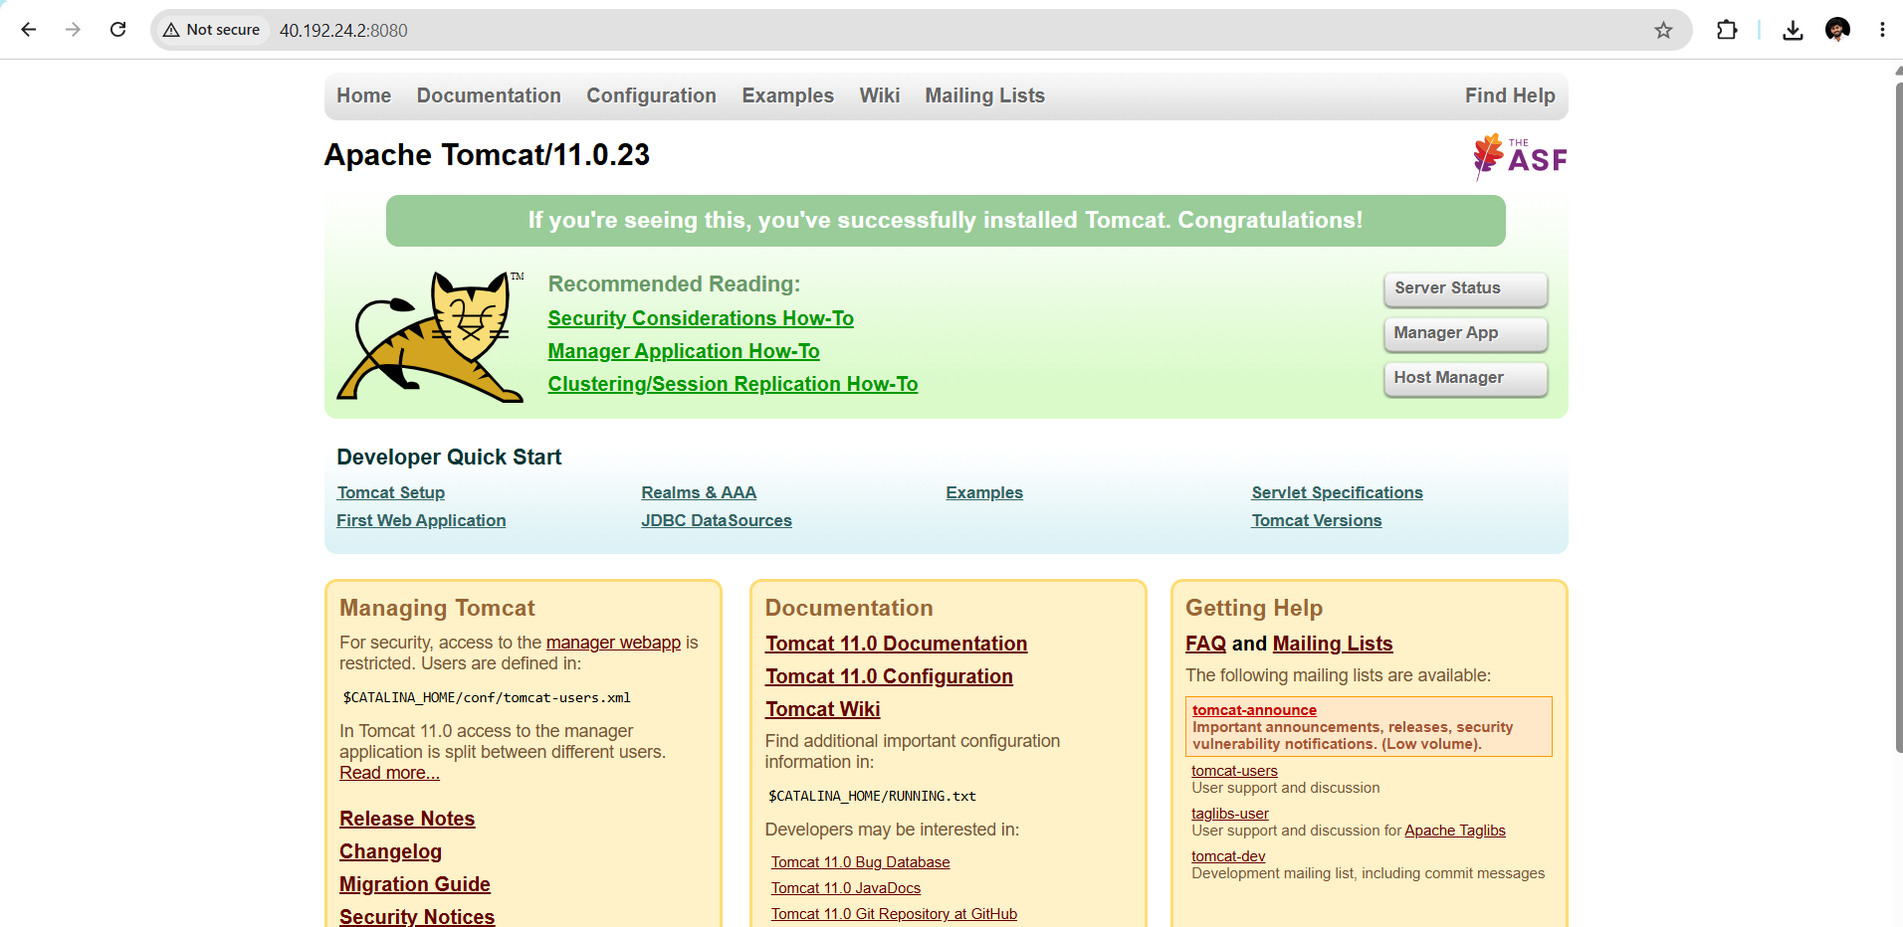

6. Check if Nginx is Running
Step 1
vi nginx_status.sh
Step 2
#!/bin/bash

if systemctl is-active --quiet nginx
then
echo "Nginx is Running"
else
echo "Nginx is Stopped"

sudo systemctl start nginx

echo "Nginx Started Successfully"
fi
Step 3
chmod +x nginx_status.sh
Step 4
./nginx_status.sh
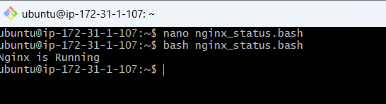

- Calculator:
Step 1
vi calculator.sh
Step 2
#!/bin/bash

echo "Enter First Number"

read num1

echo "Enter Second Number"

read num2

echo "Choose Operator (+,-,*,/)"

read op

case $op in

+)
echo $((num1+num2))
;;

-)
echo $((num1-num2))
;;

\*)
echo $((num1*num2))
;;

\/)
echo $((num1/num2))
;;

*)
echo "Invalid Operator"

;;

esac
Step 3
chmod +x calculator.sh
Step 4
./calculator.sh

Example

Enter First Number
10

Enter Second Number
20

Choose Operator
+

30

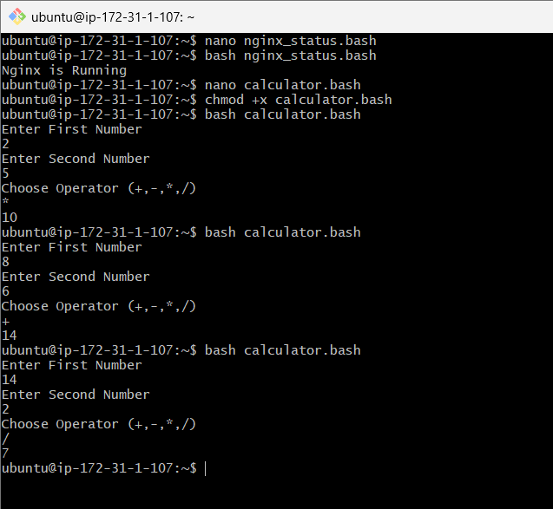

8. Create Directory if Not Exists
Step 1
vi create_directory.sh
Step 2
#!/bin/bash

DIR="/home/ubuntu/Sample_Directory"

if [ -d "$DIR" ]
then
echo "Directory already exists."
else
mkdir -p "$DIR"

echo "Directory Created."
fi

Step 3
chmod +x create_directory.sh
Step 4
./create_directory.sh
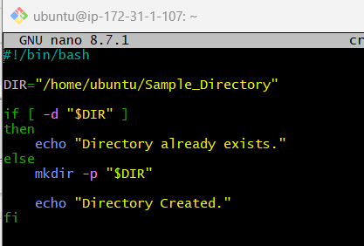
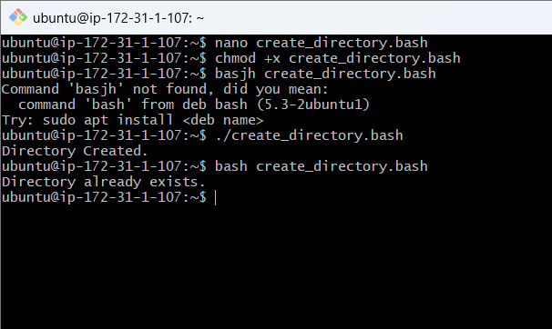

9. Delete Last 3 Lines of a File
Step 1

Create a sample file

vi sample.txt

Add

Line1
Line2
Line3
Line4
Line5
Line6
Step 2

Create script

vi delete_last3.sh
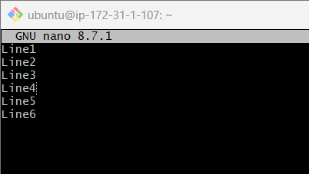
Step 3
#!/bin/bash

FILE="sample.txt"

head -n -3 $FILE > temp.txt

mv temp.txt $FILE

echo "Deleted Last 3 Lines"
Step 4
chmod +x delete_last3.sh
Step 5
./delete_last3.sh

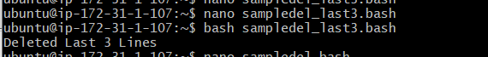
Step 6

Verify

cat sample.txt
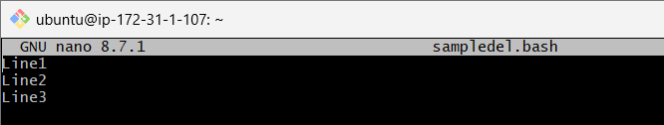

Output

Line1
Line2
Line3

10. CPU Usage Monitoring (>80%)
Step 1
vi cpu_monitor.sh
Step 2
#!/bin/bash

THRESHOLD=80

CPU=$(top -bn1 | grep "Cpu(s)" | awk '{print int(100-$8)}')

if [ "$CPU" -gt "$THRESHOLD" ]
then
echo "CPU Usage is $CPU%" | mail -s "CPU Alert" admin@example.com
fi
Step 3
chmod +x cpu_monitor.sh
Step 4
./cpu_monitor.sh
O/P: Nothing will return

Script2:
nano cpu_monitor2.bash

#!/bin/bash
THRESHOLD=80
CPU=$(top -bn1 | grep "Cpu(s)" | awk '{print int(100-$8)}')
echo "Current CPU Usage: $CPU%"
if [ "$CPU" -gt "$THRESHOLD" ]
then
echo "CPU Usage is $CPU%"
fi
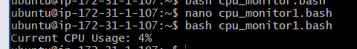

11. Disk Usage Monitoring (>80%)
Step 1
vi disk_monitor.sh
Step 2
#!/bin/bash

THRESHOLD=80

USAGE=$(df -h / | awk 'NR==2 {print $5}' | sed 's/%//')

if [ "$USAGE" -gt "$THRESHOLD" ]
then
echo "Disk Usage is $USAGE%" | mail -s "Disk Alert" admin@example.com
fi
Step 3
chmod +x disk_monitor.sh
Step 4
./disk_monitor.sh

12. Memory Usage Monitoring (>80%)
Step 1
vi memory_monitor.sh
Step 2
#!/bin/bash

THRESHOLD=80

MEM=$(free | awk '/Mem/ {print int($3/$2*100)}')

if [ "$MEM" -gt "$THRESHOLD" ]
then
echo "Memory Usage is $MEM%" | mail -s "Memory Alert" admin@example.com
fi
Step 3
chmod +x memory_monitor.sh
Step 4
./memory_monitor.sh
Common Execution Steps (Applicable to All Scripts)

Create the script:

vi script_name.sh

Add the shebang:

#!/bin/bash
Write the script logic.
Save and exit:
Press Esc
Type :wq
Press Enter

Give execute permission:

chmod +x script_name.sh

Run the script:

./script_name.sh
Verify the output using the appropriate command (for example, ls, cat, systemctl status, or curl depending on the script).

Memory Monitoring Bash Script
#!/bin/bash

THRESHOLD=80

MEM=$(free | awk '/Mem/ {print int($3/$2*100)}')

echo "Current Memory Usage: $MEM%"

if [ "$MEM" -gt "$THRESHOLD" ]
then
echo "Memory Usage is above the threshold."
echo "Memory Usage is $MEM%" | mail -s "Memory Alert" admin@example.com
else
echo "Memory Usage is under control."
fi
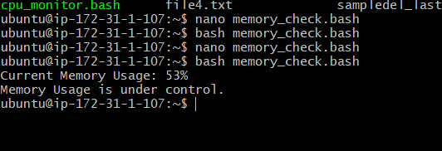

Line 1
#!/bin/bash
Explanation
- This is called the Shebang.
- It tells Linux to execute the script using the Bash shell.

Line 2
THRESHOLD=80
Explanation
- Creates a variable called THRESHOLD.
- Stores the value 80, which represents 80% memory usage.
- This value is used to decide when to send an alert.
Example:
THRESHOLD = 80%

Line 3
MEM=$(free | awk '/Mem/ {print int($3/$2*100)}')
This line calculates the current memory usage percentage.
Let's break it down.

Step 1: free
free
The free command displays memory (RAM) information.
Example output:
total used free shared buff/cache available
Mem: 3988760 1210000 820000 20000 1958760 2500000
Swap: 0 0 0

Step 2: Pipe (|)
free | awk ...
The pipe (|) sends the output of free to awk.
free command
│
▼
awk command

Step 3: awk
awk '/Mem/ {print int($3/$2*100)}'
awk processes the text output from free.
/Mem/
/Mem/
Selects only the line that starts with Mem:.
Example:
Mem: 3988760 1210000 820000 ...

$2
Represents the second column, which is the total memory.
Example:
Mem: 3988760 1210000 820000
↑
$2 = Total Memory

$3
Represents the third column, which is the used memory.
Example:
Mem: 3988760 1210000 820000
↑
$3 = Used Memory

Calculation
$3/$2*100
Formula:
Used Memory
──────────── × 100
Total Memory
Example:
Total Memory = 4000 MB
Used Memory = 3000 MB
3000 ÷ 4000 × 100 = 75%

int()
int(...)
Removes the decimal part.
Example:
75.86
becomes
75

Step 4: $(...)
$(command)
This is called command substitution.
It runs the command and stores its output.
Example:
MEM=$(free | awk '/Mem/ {print int($3/$2*100)}')
If the command returns:
42
Then:
MEM = 42

Line 4
if [ "$MEM" -gt "$THRESHOLD" ]
Explanation
Checks whether the current memory usage is greater than the threshold.
Example:
MEM = 85
THRESHOLD = 80
The condition becomes:
85 -gt 80
Since 85 is greater than 80, the condition is true.

-gt
-gt means greater than.
Other comparison operators:
Operator | Meaning
-gt | Greater than
-lt | Less than
-eq | Equal to
-ge | Greater than or equal to
-le | Less than or equal to
-ne | Not equal to

Line 5
then
Explanation
If the condition is true, execute the commands below.

Line 6
echo "Memory Usage is $MEM%" | mail -s "Memory Alert" admin@example.com
echo
Prints the message:
Memory Usage is 85%
(if MEM=85).
Pipe (|)
Sends the message from echo to the mail command.
mail
mail -s "Memory Alert" admin@example.com
- mail sends an email.
- -s sets the email subject.
Subject:
Memory Alert
Email body:
Memory Usage is 85%
Recipient:
admin@example.com
Note: admin@example.com is a sample address. To actually receive emails, you need to replace it with a real email address and have a mail server configured.

Line 7
fi
Marks the end of the if statement.

Complete Workflow
Start
│
▼
Set THRESHOLD = 80
│
▼
Run free command
│
▼
Get Total Memory ($2)
Get Used Memory ($3)
│
▼
Calculate Used Memory %
│
▼
Store result in MEM
│
▼
Is MEM > 80?
│
┌─┴──────────────┐
│ │
Yes No
│ │
▼ ▼
Send Email Exit Script
Example
Suppose your system has:
Total Memory = 8000 MB
Used Memory = 6800 MB
Calculation:
6800 ÷ 8000 × 100 = 85%
The script stores:
MEM=85
Then it checks:
85 > 80
Since the condition is true, it sends an email with:
- Subject: Memory Alert
- Body: Memory Usage is 85%
If the memory usage were 55%, the condition would be false, and the script would simply end without sending an email.

